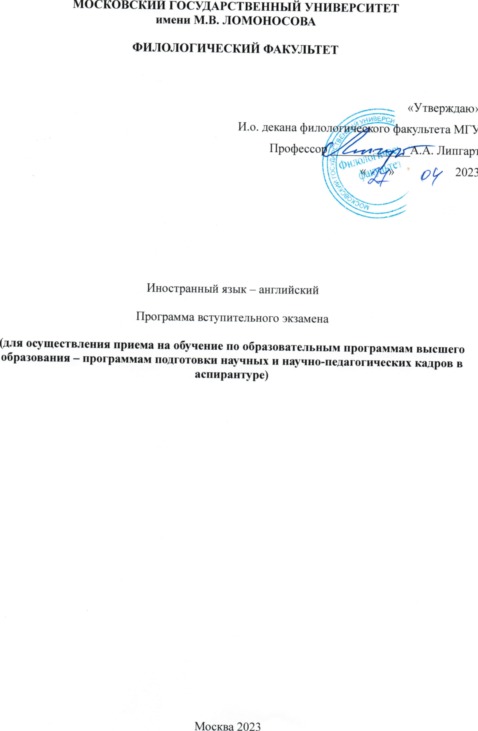

ПРОГРАММА
вступительного экзамена в аспирантуру филологического факультета по иностранному (английский язык)
Общие требования
Поступающие в аспирантуру филологического факультета должны обладать общенаучными знаниями и компетенциями, полученными в процессе обучения по программе ВПО по направлению «специалист», «магистр», «бакалавр»,
а также специальными знаниями и инструментальными компетенциями, позволяющими владеть нормой родного и иностранного языка в устной и письменной форме, владеть терминологией специализированной области знания, иметь навыки перевода с языка оригинала на язык цели, реферирования текста на иностранном языке,

Программа экзамена по иностранному языку включает:
1. Письменный перевод с иностранного языка на русский язык текста объемом не менее 2500 знаков обще-филологической , историко-культурологической проблематики или публицистической направленности. Краткое резюме текста на иностранном языке (до 50 слов)
Время выполнения задания - 90 мин.
2. Устное собеседование позволяет выявить специализированные компетенции поступающего в аспирантуру в области ведения коммуникации на иностранном языке, его системные представления в области исследования, глубину его знаний в области литературной нормы родного и иностранного языка, его профессиональные компетенции;
Собеседование на иностранном языке имеет вопросно-ответную форму проведения.
Экзамен призван выявить уровень владения иностранным языком, литературной нормой русского языка, правилами лексико-грамматической сочетаемости родного и иностранного языка.

Поступающие в аспирантуру могут познакомиться с образцами текстов на английском языке для письменного перевода в изданиях:

van Dijk T.A. Discourse and Power. 2008
Crystal David The Cambridge Encyclopedia of Language. CUP.1987
Eckert Penelope, McConnell-Ginet Sally Language and Gender. CUP-2003
Комова Т.А. History, Philology and Culture. (A book for reading, enjoying and study). Moscow - 1997
Leech G. Language in Literature. Style and Foregrounding. 2008
Widdowson H. G. Linguistics. OUP-2002
Литература по английскому языку:
Словари
Ахманова О.С. Словарь лингвистических терминов (любой год издания)
Гвишиани Н.Б. Терминология в обучении английскому языку с «Глоссарием лингвистических терминов». М.:1993
Crystal D. The Cambridge Encyclopedia of Language. - CUP.1987 Грамматики
Aleksandrova O.V., Komova T.A. Modern English Grammar: Morphology
and Syntax. M.: 2013
Lyons J. Introduction to Theoretical Linguistics. CUP - 1971
Виноградов В.В. Русский язык. Грамматическое учение о слове. М.:1986

Образец текста (английский язык):
1.Beauty* is found in the women of the three types, Nordic, Mediterranean and Alpine, but the fundamental and dominating feature of them all is the Mediterranean, and there is a natural tendency among women to revert to this dark, long-headed, oval-faced type; in fact, the pictures of the ancient Cretan women with their dark curly hair, large eyes and tip-tilted noses are reproduced to-day, especially among the Irish. On the other hand there is the artificial force at work tending to draw the race away from this type and to evolve a negative, average woman. The result will depend on the freedom of the males to make their choice, and this is likely to increase. It is an important factor, as those who have acquaintance with lower middle-class nonconformists will realize. There the influence of the "chapel-connection" is very strong, and the tendency when I was a boy was to induce a young man to marry a godly young woman well known is his circle. To marry for beauty was considered a deadly sin, and the tenets of Christianity were invoked in the interests of mortification of the flesh. This debased, Alpine-Puritan-Nonconformist ideal is responsible for much of the appalling ugliness we see around us to-day, both physical and artistic. During the war London was crowded with beautiful women, the bolder and more enfranchised spirits being drawn into public activity from all corners of the country. When the war ceased there was a sad reversion, and we meet more of the spectacled, long-faced, adenoid-jawed, the products of an uneugenic religion, malnutrition, bad social conditions and race reversion. But there are signs that the pretty, well-dressed London girl is reasserting herself.
On the whole, in comparing the beauty of the Italian woman and the charm of the French with the average, uncomely lower-middle class women of our own country, I cannot help feeling that we are suffering from the sins of our fathers in neglecting life and the body for a problematic advantage hereafter. Fortunately the neo-Georgian feeling for beauty is doing what it can to restore the race.

2.LITERATURE AND ART
If literature were a criterion of a people's worth, England would stand very high indeed. But such a criterion would be unfair to peoples like the Romans or Americans who have excelled in action rather than expression. As the dream expresses the unconscious wishes and fears of the individual, so literature with the other arts betrays the unconscious spirit of a people. Literature reveals their hopes and their fears, and it is but natural that its exponents should be of that type of humanity which is closest to nature and the unconscious. The more a people is dominated by its conscious, the less will it express itself in literature although by a strange exception it may do so in music. Thus the Greeks, with their strong Mediterranean admixture, rank high in the world of letters; Germany also, before the Prussian domination; for both could give free rein to their unconscious impulse; because she could not, Rome ranks low. But there are two elements in art and literature; the dynamic and the static, inspiration and control; the former is a long-headed character, and the latter short-headed. Thus peoples deficient in one or the other element are deficient in expression. The Irish incline to exhibit too much exuberance, the Romans too little.
England is fortunate in the same way as the Greeks in having the two racial elements powerfully developed. The Nordic is not a maker of literature, nor does he understand it, but he is nevertheless often a good patron. Our creative writers have been mainly of the Mediterranean type and Keats was an outstanding example; the architectonics and moral fibre of Shakespeare on the other hand betray a short-headed strain, which reminds us that the true Nordic makes one great contribution to literature in that he at least inspires great poetry; thus Nordic heroes are the great figures of the Homeric poems, of the Sagas, whilst Shakespeare presents us with a galaxy.
Since a people tends to work off its complexes and obsessions in its poetry, it generally follows that the literature of fear is greater than the literature of joy, for in the former the unconscious has freer play. Thus the Greeks excelled in tragedy while the Romans, practical men of action, made no mark therein. We are reminded again of the difference between the Protestant spirit and the Catholic, or between the Alpine and the Mediterranean, the former dominating God and the second dominated by Him. The Romans had little fear from the outside world, although tradition led them to toy with it; but with the Greeks this fear, together with a dread of incest arising from a pristine uncertainty in marital relations, was a real dread which inspires their greatest work.
While Shakespeare's expression is on the whole strong and jubilant there are occasional phases of some such similar terror which may be of a personal nature, and under their influence, as in Macbeth or King Lear, he is at his greatest.
Apart from their terror-complex, the Greeks excelled in clear vision and lucid expression, a tradition passed on to the French. Apart from a temporary depression in the Romantic period the French have pursued the cult of joie de vivre and lucidity, and their literature abounds in wit rather than humour.
As a racial study it is interesting to view English literature from the standpoint of both French and German. That the French have a substratum of the more virile qualities of letters is shown by Rabelais and Montaigne, by Hugo, Sand and Balzac but, as happened with Gray, the flame seems to have been quenched by atmosphere, the atmosphere in their case of the salon. The rough worlds and thoughts of the peasant and artisan, so rich in meaning, so close to nature, which humanize the pages of Shakespeare are taboo in French literature; the feeling for the country, for nature, for elemental passions, such as is found in Hamsun's Growth of the Soil, are not conspicuous. Moliere, a master of stage-craft, a specialist in character, yet portrays the character rather than the human being. The French are bound by convention while the English are most excellent in breaking it. The French never forget their formal classic laws, while the English had the advantage of never knowing them.
* R. N. Bradley. Racial Origins of English Character. London, 1926, pp. 105 - 138.

